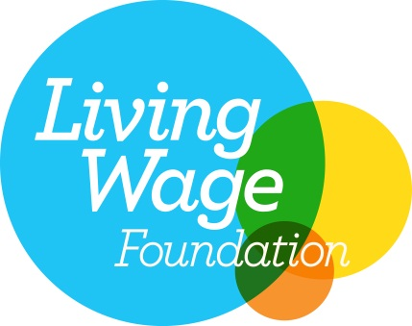
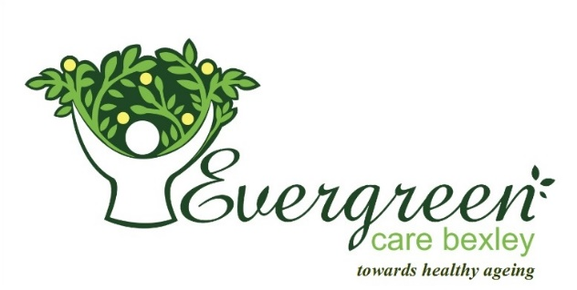

EVERGREEN CARE BEXLEY CELEBRATES LIVING WAGE COMMITMENT

The Living Wage Foundation is pleased to announce that Evergreen Care Bexley has today accredited as a Living Wage employer.

The Living Wage commitment will see everyone working at Evergreen Care Bexley, regardless of whether they are permanent employees or third-party contractors; receive a minimum hourly wage of £9.75 - significantly higher than the national minimum wage of £6.95 and the new minimum wage premium for over 25s of £7.20 per hour introduced this April.

The Living Wage is an hourly rate set independently and updated annually. The Living Wage is calculated according to the basic cost of living using the ‘Minimum Income Standard’ for the UK. Decisions about what to include in this standard are set by the public; it is a social consensus about what people need to make ends meet.

“The ethos of Evergreen has always been to ‘look after our staff as well as we look after our clients’. By becoming a Living Wage Employer we are showing our appreciation to our staff for their hard work and commitment to their clients and to Evergreen”.

Employers choose to pay the Living Wage on a voluntary basis. The Living Wage enjoys cross party support, with public backing from the Prime Minister and the Leader of the Opposition.

Living Wage Foundation Director, Katherine Chapman said: “We are delighted to welcome Evergreen Care Bexley to the Living Wage movement as an accredited employer.

“The best employers are voluntarily signing up to pay the Living Wage now. The Living Wage is a robust calculation that reflects the real cost of living, rewarding a hard day’s work with a fair day’s pay.
“We have accredited nearly 3,000 leading employers, including Evergreen Care Bexley, ranging from independent printers, bookshops and breweries, to well-known companies such as Nationwide, Aviva and SSE. These businesses recognise that clinging to the National Living Wage is not good for business. Customers expect better than that."

Shazia Ejaz, shazia.ejaz@citizensuk.org
Or

Esmat Jeraj, 07809608786, esmat.jeraj@citizensuk.org

